**Student Number : 14338471**

**Student Name: Bibek Bhandari**

**Subject: 31061 32606 Database Principles - Spring**

**1)** **Using ED, get the output shown below.**

**2)** **Upload on to canvas the screenshot of your output along with your SQL code.**

**Question 1.**

List all astronauts’ names, year of death, and age at year of death who died at the age of 57.

Query:  
select astroname as "AstroName", death as "Passed away", death-birth as "AstronautAge" from nasa2_astronaut where death-birth = 57;

**Query+Output**

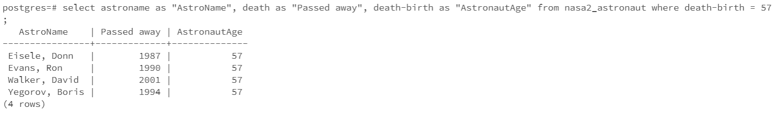

**Question 2.**

List the missions (projectname, missionno) and launchYear of all missions launched before 1985 by spacecraft named “Challenger”. Order by the launch year.

Query: select distinct projectname, missionno, launchYear

from NASA2_Mission natural join NASA2_Spacecraft

where Craftname = 'Challenger' and launchYear < 1985

order by launchYear;

**Query+Output**

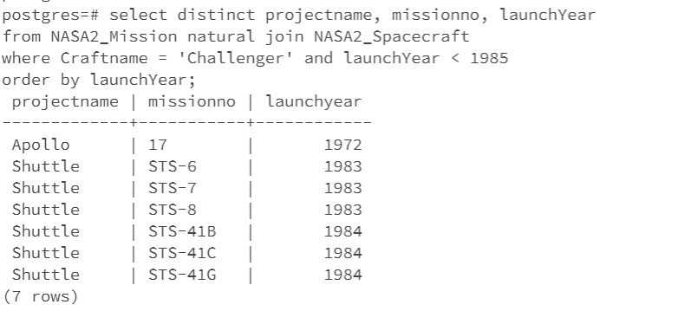

**Question 3.**

Re-express the above natural join query as a cross product

Query: select NASA2_Mission.projectname, NASA2_Mission.missionno, launchYear

from NASA2_Mission, NASA2_Spacecraft

where NASA2_Mission.projectname = NASA2_Spacecraft.projectname

and NASA2_Mission.missionno = NASA2_Spacecraft.missionno

and Craftname = 'Challenger' and launchYear < 1985

order by launchYear;

Query+Output

